Hong Kong Exchanges and Clearing Limited and The Stock Exchange of Hong Kong Limited takes no responsibility for the contents of this announcement, makes no representation as to its accuracy or completeness and expressly disclaims any liability whatsoever for any loss however arising from or in reliance upon the whole or any part of the contents of this announcement.

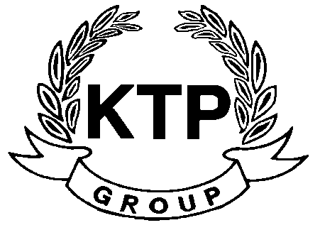
KTP HOLDINGS LIMITED
港台集團有限公司*
(Incorporated in Bermuda with limited liability)
(Stock Code: 645)

Disclosure pursuant to Rule 13.09 of the Listing Rules

The Board wishes to inform to the shareholders and investors of the Company that the Group has ceased to manufacture the OEM footwear products for its major customer. As such, the Group’s turnover for the year ending 31 March 2010 will be materially and adversely affected by the reduction of the OEM footwear orders from its major customer.

Shareholders of the Company and investors are advised to exercise caution when dealing in the shares of the Company.

At the request of the Company, trading in the shares of the Company on the Stock Exchange was suspended with effect from 2:30 p.m. on Wednesday, 6 May 2009. An application has been made by the Company for resumption of trading in its shares with effect from 9:30 a.m. on 7 May 2009.

The board of directors (the “Board”) of KTP Holdings Limited (the “Company” and together with its subsidiaries, the “Group”) wishes to inform to the shareholders and investors of the Company that the Group has ceased to manufacture the OEM footwear products for its major customer after failing to negotiate a feasible pricing model with its major customer. As such, the Group’s turnover for the year ending 31 March 2010 will be materially and adversely affected by the reduction of the OEM footwear orders from its major customer.

The Board has realized the increasingly competitive operating environment of footwear OEM business over the last few years and mentioned in the previous annual report of the Company. Global financial turmoil is an accelerating factor of the cessation of manufacturing the OEM footwear products for its major customer. The amount of turnover attributable to such major customer represented 60% of the Group’s total turnover of footwear products for the year ended 31 March 2009.

Although the turnover of the Group for the year ending 31 March 2010 should be substantially reduced due to the reduction of the OEM footwear orders from its major customer, the Group continues to maintain the manufacturing of footwear products and monitor the Company’s overall operational business and it is considered that the Group’s operational and financial position is stable.

By adopting a prudent approach, the Company will continue to identify and evaluate any business opportunities in footwear industry despite the global financial turmoil and the increasing cost of production in the People’s Republic of China.

Shareholders of the Company and investors are advised to exercise caution when dealing in the shares of the Company.

At the request of the Company, trading in the shares of the Company on the Stock Exchange was suspended with effect from 2:30 p.m. on Wednesday, 6 May 2009. An application has been made by the Company for resumption of trading in its shares with effect from 9:30 a.m. on 7 May 2009.

By the Order of the Board
KTP HOLDINGS LIMITED
Lee Chi Keung Russell
Chairman

Hong Kong, 6 May 2009

*For identification purpose only

As at the date of this announcement, the Board is comprised of 5 Directors, of which Mr. LEE Chi Keung, Russell and Miss. YU Mee See, Maria are executive Directors, Mr. NG Wai Hung, LEE Siu Leung and Mr. YUEN Sik Ming are independent non-executive Directors.

